

Maja Mysliwiec

healthcare clinic
Logo / Image

Contents
Business Description 3
1.1 the Benefits of implementing a database. Project Vision 3
2 Model description 3
2.1 Definitions & Acronyms 3
2.2 Logical Scheme 3
2.3 Objects 3

Business Description

the Benefits of implementing a database. Project Vision
Implementing this database centralizes the management of appointments, staff, and pricing, effectively eliminating the redundancy of scattered or paper-based records. The system ensures data integrity and consistency through strict foreign key relationships and defined data types, while traceability is supported by automatic timestamps on record creation. To maintain accurate historical records without overwriting past facts, the model utilizes a dedicated status history table to log all appointment state changes and freezes the exact billed amounts within the services table during each visit. Designed in the Third Normal Form (3NF), the database architecture allows the clinic to seamlessly scale operations—such as adding new staff roles or medical procedures—without requiring major structural redesigns. Finally, built-in constraints including unique identifiers, non-negative price checks, and logical schedule boundaries ensure that the data remains accurate and reliable as the volume grows.

Model description

Definitions & Acronyms
To properly interpret the model, a few key concepts require clarification. The design frequently uses junction tables to resolve complex many-to-many relationships into manageable assignments, such as linking specific medications to prescriptions. It is also crucial to distinguish between the current price, which acts as the active catalog rate for a medical service, and the charged price, which represents the specific, frozen amount billed during a historical visit. Additionally, the database employs a recursive relationship within the staff hierarchy, meaning a staff record can reference another individual within the exact same table to clearly establish a supervisor-subordinate dynamic.

Logical Scheme
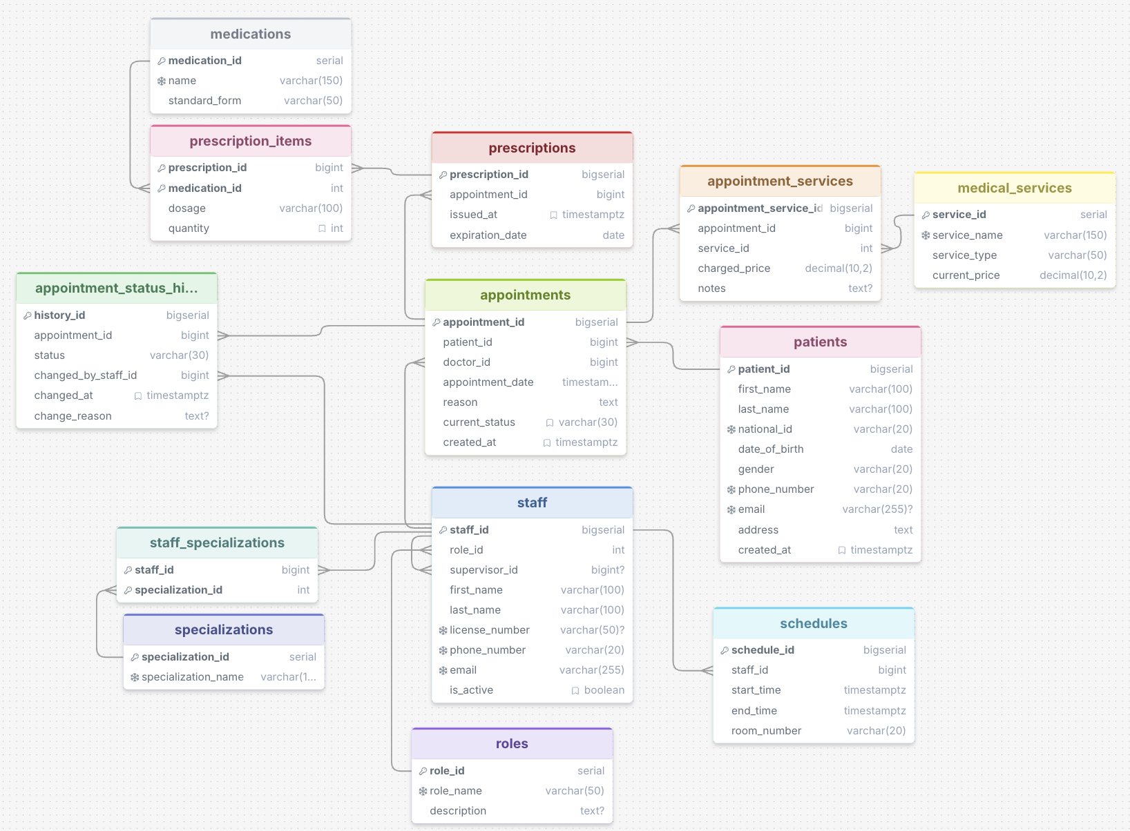
The most difficult modeling decision was establishing a reliable historical billing logic; instead of linking visits directly to the main service catalog, an intermediate table was introduced to freeze the billed amounts, thereby protecting past financial records from future catalog updates. This structural separation, combined with strict database constraints, prevents common data anomalies like overlapping staff schedules or the need to update a doctor's personal details multiple times across different prescriptions. The model remains highly scalable for future additions, leveraging flexible role assignments and artificial primary keys to handle expanding datasets efficiently. Should the clinic's business requirements grow significantly, the area most likely to undergo major changes would be the billing and payment’s structure, which would eventually require a dedicated accounting module linked to the current appointments system.

Objects
patients
This table represents individuals receiving medical care at the clinic, storing their personal and contact information. It must be stored separately to act as a central master record, preventing data duplication across multiple appointments and ensuring updates happen in one place. The table is normalized to the Third Normal Form (3NF) because all non-key attributes depend entirely and solely on the primary key, with no repeating groups (1NF) and no partial dependencies (2NF). Potential transitive dependencies were eliminated by ensuring fields like contact details directly describe the patient; all attributes depend only on the key. I chose a surrogate auto-incrementing primary key because natural composite keys like first and last names are not universally unique and can change; no foreign keys were necessary here as this is a top-level master data entity.

Field Name | Field Description | Data Type
patient_id | Unique identifier for the patient, PK | BIGSERIAL
first_name | Patient's first name | VARCHAR(100)
national_id | Unique national identification number | VARCHAR(20)
phone_number | Patient's contact phone number | VARCHAR(20)

patient_id | first_name | national_id | phone_number
1 | John | 85031212345 | 555-123-456
2 | Anna | 90052498765 | 555-987-654

roles
This table represents the specific job positions or administrative classifications assigned to clinic employees. It is stored separately as a dictionary table to standardize job titles and descriptions across the system, allowing easy updates to a role without modifying every staff member's record. The table achieves 3NF because its attributes (name and description) are fully functionally dependent solely on the primary key. There are no partial or transitive dependencies to eliminate. A simple surrogate primary key was chosen for efficient indexing and joining; a composite key would be unnecessary overhead for a dictionary table, and no foreign keys are required.

Field Name | Field Description | Data Type
role_id | Unique identifier for the staff role, PK | SERIAL
role_name | Standardized name of the role | VARCHAR(50)
description | Detailed explanation of role responsibilities | TEXT

role_id | role_name | description
1 | Doctor | Providing medical consultations and treatments
2 | Nurse | Assisting in procedures and patient care

specializations
This table represents the medical expertise areas available within the clinic. It must be isolated as a reference dictionary to maintain consistent terminology and allow multiple doctors to share the exact same specialization definition. The table is in 3NF, containing only a primary key and the specialization name, ensuring complete functional dependency on the key. It has absolutely no partial or transitive dependencies. I utilized a surrogate primary key to link efficiently with junction tables; a composite key is not applicable for a single-attribute dictionary, and it holds no foreign keys.

Field Name | Field Description | Data Type
specialization_id | Unique identifier for the medical field, PK | SERIAL
specialization_name | Standardized name of the medical expertise | VARCHAR(100)

specialization_id | specialization_name
1 | Cardiology
2 | Pediatrics

staff
This table represents the clinical and administrative personnel working at the healthcare facility. Storing staff data separately centralizes employee contact and license details, keeping them independent from transactional records like schedules and appointments. Normalized to 3NF, the table ensures that all personal attributes depend strictly on the staff ID. Transitive dependencies regarding job descriptions were eliminated by referencing the roles table instead of storing the title text directly. I chose a surrogate primary key for consistency and added foreign keys to link the employee to their role and to establish a recursive relationship indicating their supervisor.

Field Name | Field Description | Data Type
staff_id | Unique identifier for the employee, PK | BIGSERIAL
role_id | Reference to the employee's job position, FK | INT
supervisor_id | Reference to the employee's manager, FK | BIGINT
last_name | Employee's last name | VARCHAR(100)

staff_id | role_id | supervisor_id | last_name
10 | 1 | NULL | Smith
11 | 2 | 10 | Adams
staff_specializations
This table represents the real-world assignment of specific medical specializations to individual doctors. It must exist separately to resolve the many-to-many relationship between staff and specializations, as one doctor can have multiple expertises and one expertise can belong to multiple doctors. It complies with 3NF because it contains no non-key attributes that could cause transitive dependencies. Since it is a pure junction table, I implemented a composite primary key consisting of the two associated foreign keys; utilizing a separate surrogate key here would add unnecessary complexity without functional benefit.

Field Name | Field Description | Data Type
staff_id | Reference to the doctor, PK/FK | BIGINT
specialization_id | Reference to the medical expertise, PK/FK | INT

staff_id | specialization_id
10 | 1
10 | 2

schedules
This table represents the working shifts and room assignments for the medical staff. It is separated from the staff table to respect the 1NF requirement by avoiding repeating groups of working hours within an employee's profile. The table achieves 3NF as the shift times and room numbers depend entirely on the specific schedule block identifier. No partial or transitive dependencies exist because location and time define the shift itself, not the employee. A surrogate primary key was chosen to uniquely identify each shift block, alongside a foreign key connecting the schedule to the specific staff member.

Field Name | Field Description | Data Type
schedule_id | Unique identifier for the working shift, PK | BIGSERIAL
staff_id | Reference to the assigned employee, FK | BIGINT
start_time | Timestamp when the shift begins | TIMESTAMP
room_number | Designation of the working location | VARCHAR(20)

schedule_id | staff_id | start_time | room_number
500 | 10 | 2026-10-25 08:00:00 | 101A
501 | 11 | 2026-10-25 09:00:00 | 102B

appointments
This table represents the central event of a patient visiting a doctor at a scheduled time for a specific reason. It is isolated to serve as the core transactional entity that ties together the patient, the practitioner, and subsequent medical actions without cluttering master data tables. Normalized to 3NF, every attribute like date, reason, and status depends strictly on the appointment identifier. Transitive dependencies regarding patient demographics or doctor credentials are automatically prevented by relying on foreign keys. I assigned a surrogate primary key to handle millions of records efficiently, and included foreign keys to explicitly link the corresponding patient and doctor.

Field Name | Field Description | Data Type
appointment_id | Unique identifier for the scheduled visit, PK | BIGSERIAL
patient_id | Reference to the visiting patient, FK | BIGINT
doctor_id | Reference to the attending physician, FK | BIGINT
appointment_date | Timestamp of the scheduled meeting | TIMESTAMP

appointment_id | patient_id | doctor_id | appointment_date
1001 | 1 | 10 | 2026-10-26 10:00:00
1002 | 2 | 10 | 2026-10-26 10:30:00

appointment_status_history
This table represents the sequential audit log of state changes for any given appointment. It must be kept separately to fulfill the business requirement of preserving historical clinical and administrative context without destructively overwriting past states. The table is in 3NF, ensuring that the status label, change reason, and timestamp depend strictly on the specific history event ID. Transitive dependencies were avoided by strictly recording the event metadata rather than duplicating appointment details. A surrogate primary key sequences the events, while foreign keys connect the audit log directly to the parent appointment and the staff member responsible for the update.

Field Name | Field Description | Data Type
history_id | Unique identifier for the status change event, PK | BIGSERIAL
appointment_id | Reference to the updated appointment, FK | BIGINT
status | The new operational state applied | VARCHAR(30)
changed_at | Timestamp of when the modification occurred | TIMESTAMP

history_id | appointment_id | status | changed_at
50 | 1001 | Scheduled | 2026-10-24 09:00:00
51 | 1001 | In Progress | 2026-10-26 10:05:00

medical_services
This table represents the catalog of billable procedures and treatments offered by the clinic. It is stored independently to maintain a single source of truth for current pricing and service categorizations, simplifying global price updates. The structure meets 3NF criteria because attributes like service type and current price are directly dependent on the service ID. There are no transitive dependencies to resolve. A surrogate primary key was selected to allow flexible renaming or categorization without breaking existing relational links, and no foreign keys were required.

Field Name | Field Description | Data Type
service_id | Unique identifier for the catalog item, PK | SERIAL
service_name | Standardized name of the procedure | VARCHAR(150)
current_price | The active base cost for the procedure | NUMERIC(10,2)

service_id | service_name | current_price
3 | General Consultation | 100
4 | Blood Test Panel | 50

appointment_services
This table represents the actual treatments executed and billed during a patient's visit. It is separated from both appointments and services to resolve a many-to-many relationship while crucially freezing the historically charged price to prevent retroactive financial alterations. Designed in 3NF, the billed amount and execution notes depend entirely on this specific junction record. Transitive dependencies on the catalog's current price are eliminated by explicitly copying the monetary value at the time of service. A surrogate primary key was chosen to uniquely identify the execution instance, utilizing foreign keys to bridge the specific visit with the dictionary of medical services.

Field Name | Field Description | Data Type
appointment_service_id | Unique identifier for the executed procedure, PK | BIGSERIAL
appointment_id | Reference to the associated visit, FK | BIGINT
service_id | Reference to the catalog procedure, FK | INT
charged_price | The frozen financial amount billed at that time | NUMERIC(10,2)

appointment_service_id | appointment_id | service_id | charged_price
300 | 1001 | 3 | 100
301 | 1001 | 4 | 50

prescriptions
This table represents the official medical document authorizing medication for a patient. It requires a separate table because a single appointment can result in zero, one, or multiple prescriptions, each with distinct issue and expiration dates. The design conforms to 3NF as the date attributes depend strictly on the prescription document itself. All transitive dependencies connecting back to the patient or doctor are managed via the appointment link. I applied a surrogate primary key to identify the document uniquely, using a foreign key to attach it logically to the originating medical appointment.

Field Name | Field Description | Data Type
prescription_id | Unique identifier for the authorization document, PK | BIGSERIAL
appointment_id | Reference to the originating visit, FK | BIGINT
issued_at | Timestamp of document creation | TIMESTAMP
expiration_date | Date when the authorization becomes invalid | DATE

prescription_id | appointment_id | issued_at | expiration_date
800 | 1001 | 2026-10-26 10:15:00 | 2026-11-26
801 | 1002 | 2026-10-26 10:45:00 | 2026-11-26

medications
This table represents the dictionary of available pharmaceutical drugs that doctors can prescribe. Separating this catalog ensures uniform spelling and standardized drug forms, preventing data entry errors on individual prescriptions. The table is in 3NF, with the name and standard form directly dependent solely on the primary key. No partial or transitive dependencies are present. A surrogate primary key was implemented for straightforward relational mapping, bypassing the need for complex string-based composite keys, and it operates without foreign keys.

Field Name | Field Description | Data Type
medication_id | Unique identifier for the drug catalog item, PK | SERIAL
name | Standardized pharmaceutical name | VARCHAR(150)
standard_form | Physical form of the medication (e.g., tablet) | VARCHAR(50)

medication_id | name | standard_form
1 | Ibuprofen 400mg | Tablet
2 | Amoxicillin 500mg | Capsule

prescription_items
This table represents the specific medications, dosages, and quantities assigned within a single prescription document. It must be separate to effectively break down the many-to-many relationship between the prescription headers and the medication catalog. The structure operates in 3NF because the dosage instructions and prescribed quantities depend fully on the exact combination of the prescription and the drug. I selected a composite primary key formed by the two foreign keys representing the prescription and medication, which guarantees that a specific drug is not listed twice on the same document without adding an unnecessary surrogate identifier.

Field Name | Field Description | Data Type
prescription_id | Reference to the parent document, PK/FK | BIGINT
medication_id | Reference to the prescribed drug, PK/FK | INT
dosage | Instructions on how to consume the drug | VARCHAR(100)
quantity | Number of units prescribed | INT

prescription_id | medication_id | dosage | quantity
800 | 1 | 1 tablet every 8 hours | 20
800 | 2 | 1 capsule every 12 hours | 14

